# 1:50 Secondary View v1.2 Stored Display Upgrade

**20702: Synchronize UFM changes from Duct View**

1. Modified Duct Bank symbology to include a black outline with white fill

Before: After:

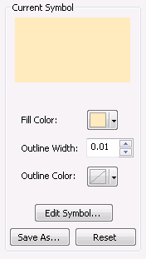 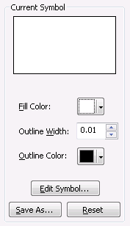

1. Modified Duct symbology to use a solid black outline with a grey fill (20%) for occuplied and a solid white fill for unoccupied

Before:

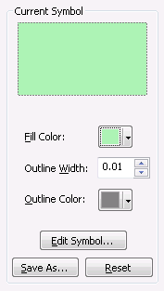 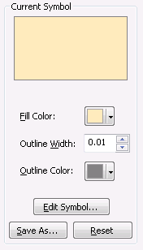

After:

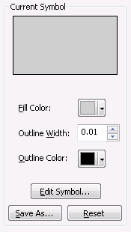 

Upon completion:

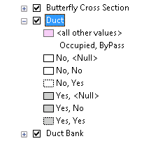

**20695: ‘Devices’ group layer changes**

Turn off Step Down; turn on Smart Meter.

Before:

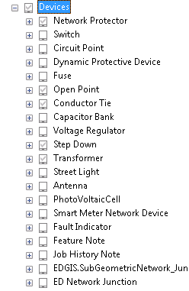 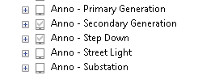

After:

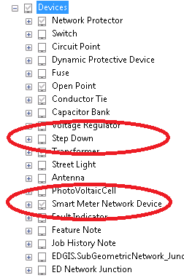 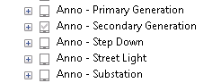

**20696: ‘Structure’ group layer changes**

Turn on Support Structure, Padmount Structure, Anchor and Guy

Before:

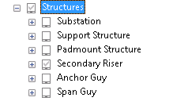 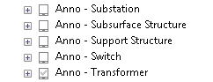

After:

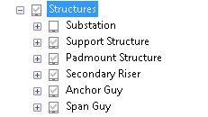 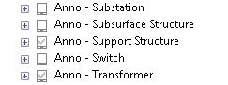

**20698: Turn of Deactivate Electric Line Segment**

Before:

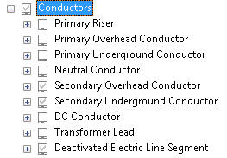 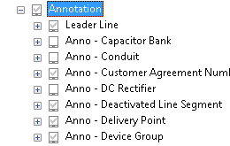

After:

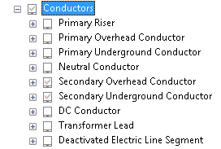 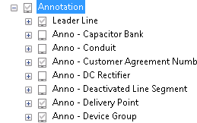

**20699: Conduit and Subsurface Structures group layer changes**

Turn on Subsurface Structure and remove Enclosures.

Before:

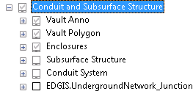 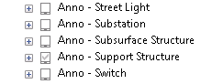

After:

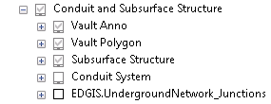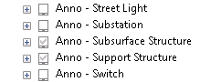

Also ensure Duct Junction is removed from Subsurface Structure and a definition query set

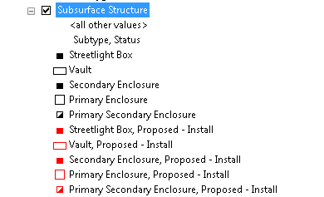

**20697: Break out pseudo secondary from secondary conductor**

Ensure that definition query on subtypes are set on all layers and turn off pseudo secondary

**Before:**

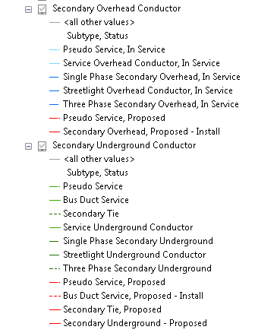

**After:**

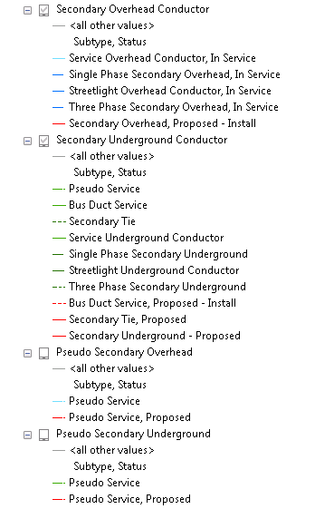

**20694: Open Point**

Update to include T Connectors, Conductor Change, Limitor, Terminator, Splice and Open Point – all filtered by Secondary IDC = ‘Y’

**Before:**

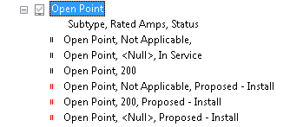

**After:**

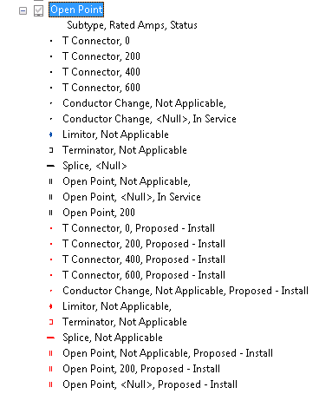

**20700: Merge DC Layers into the Secondary display**

Add or turn on DC Device, DC Rectifier, DC Conductor and DC Service Location

**Before:**

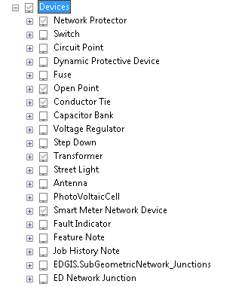

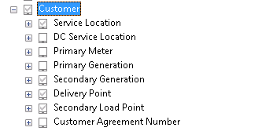



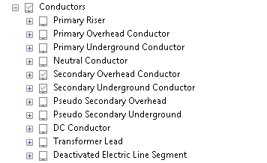

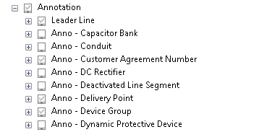

**After:**

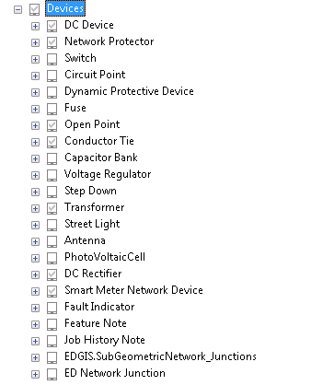

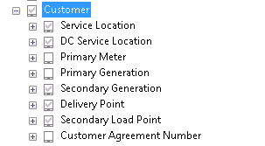



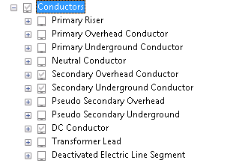

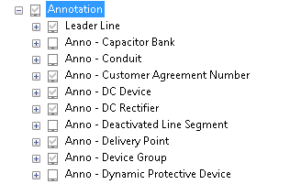

**20701: Add missing Network Protector Annotation**

